Project Time Card Auto-Approval Issue
Support request for Oracle ERP Guide (OEG) — Doubt Clarification Forum
I am configuring Oracle Fusion Cloud HCM Time and Labor integrated with Project Costing in a test environment. My objective is to auto-approve project time cards after submission. The time card continues to remain in Submitted status, and no approval task is visible to the intended approver.

1. Environment and test details
Item | Details
Application | Oracle Fusion Cloud HCM — Time and Labor / Project Costing
Workflow task | ProjectTimeCardApproval (entry-level approval is not enabled)
Time Consumer Set | Projects Only
Time Consumer | Project Costing
Worker used in the reproduced issue | Satish Das — Person Number 7846
Project / Task | Project 191204; task used in latest card: 3.1 - 191204
Expenditure Type | Miscellaneous Labor
Example time card period | 28-Sep-2026 to 04-Oct-2026
Example card status | Submitted; 50 reported/total hours; submission date 29-Sep-2026

2. Problem statement
- After submitting a project time card, its status remains Submitted instead of changing to Approved.
- No approval task appears in the logged-in user's Worklist / My Tasks, even when the user is added to the Project Time Card Approval approval group.
- The time card does not appear as a corresponding transaction in Transaction Console after refreshing and checking the relevant date range.
- No approval notification is received. The card's actions show Delete, Edit, Print, and View; the View screen does not show an Approval History action.

3. Configuration and troubleshooting already performed
- Added the worker as a labor resource/team member to the project, with Track Time enabled; project and task became available in time entry.
- Verified the worker's Projects Time Processing Profile uses the Projects Only time consumer set and a Monday-starting weekly period.
- Verified the Projects Only time consumer set uses Project Costing, with approval period Projects Weekly Starting Monday, Approval Required for Project Costing, and transfer on approval.
- Verified Enable Approval Workflow for Workers is set to No.
- Confirmed that the applicable BPM task is ProjectTimecardApproval, not ProjectTimecardApprovalELA, because entry-level approval is not enabled.
- Edited the approval rules. During validation, RUL-05721 errors reported that an expression returned Lists where String was expected. The affected values were corrected (including the IgnoreParticipant_V2 argument and Dimension Id), and subsequent validation reported no errors.
- Saved and committed the task configuration successfully; the confirmation showed 'TaskEditor Data Saved Successfully' and 'TaskEditor Data committed Successfully'.
- Tested an auto-approval rule with IF 1 is 1, Auto Action Enabled = True, and Auto Action = "APPROVE". At another point, tested the Approval Group list builder with the Project Time Card Approval group. The latest rule screenshot shows the Approval Group version, so guidance is needed on the correct final configuration for auto-approval.
- Checked profile option ORA_HRC_TRANSACTION_CONSOLE_REDWOOD_ENABLED; it exists with Site-level value Y. ORA_HRC_ARCHIVE_TXN_CONSOLE was not found.

4. Screenshots attached
The following screenshots are included as evidence of the current symptom and configuration history.

Evidence A — Submitted time card
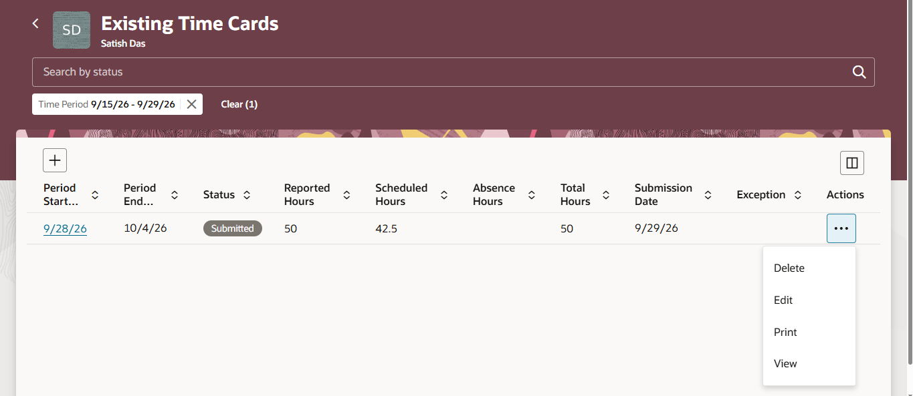
Figure A1. Existing Time Cards shows Satish Das's 28-Sep-2026 to 04-Oct-2026 card in Submitted status (50 hours).
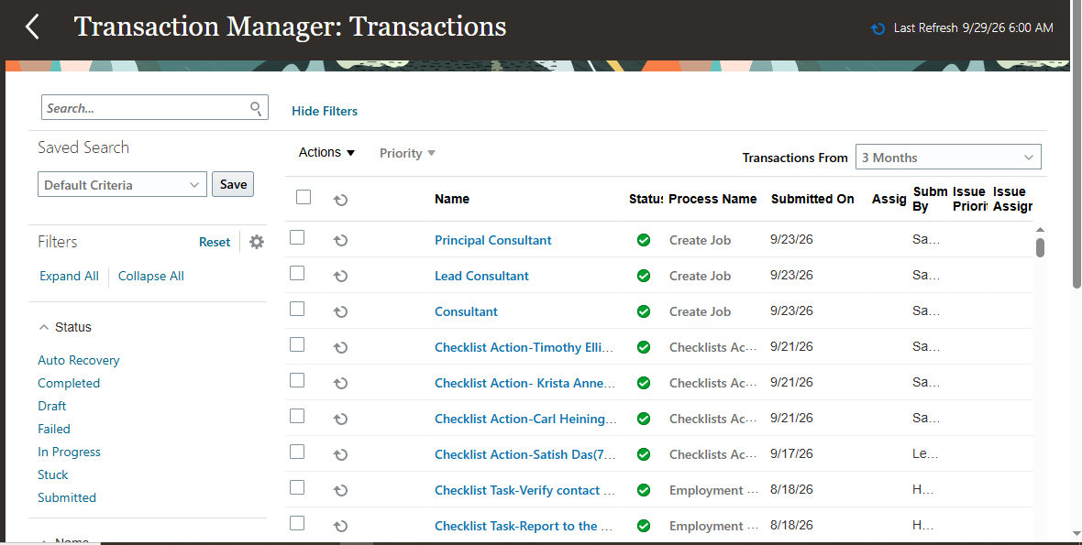
Figure A2. Transaction Console list after refresh; the submitted time card was not identifiable in the displayed transactions.

Evidence B — Approval rule configuration
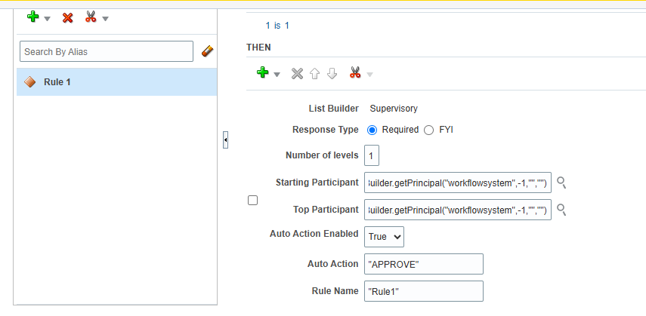
Figure B1. Earlier auto-approval rule configuration: IF 1 is 1; Supervisory list builder; Auto Action Enabled = True; Auto Action = APPROVE.
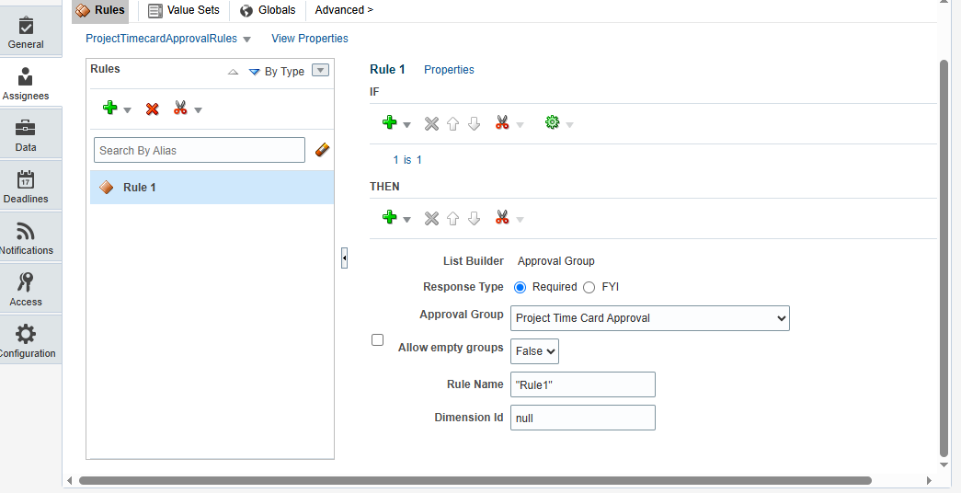
Figure B2. Later rule configuration using Approval Group = Project Time Card Approval. This was tested because no task appeared for the intended approver.

Evidence C — Task deployment and validation
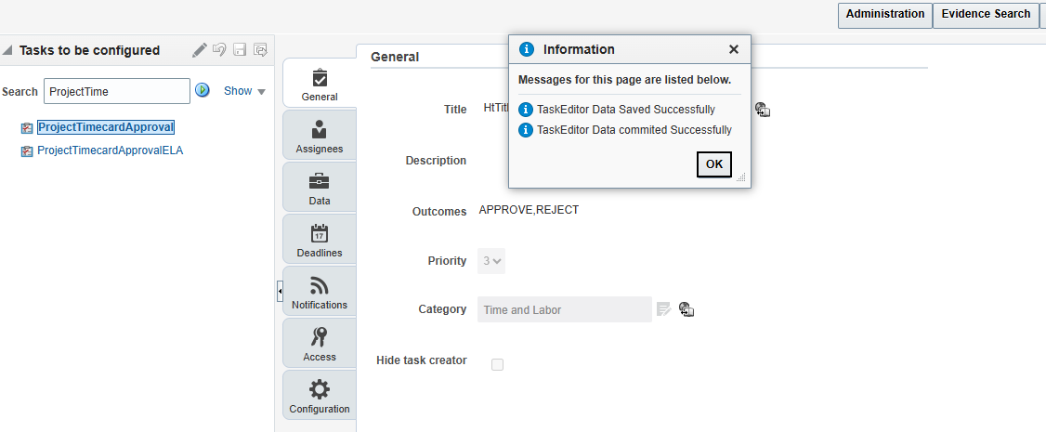
Figure C1. Task Editor confirmed that the task configuration was saved and committed successfully.
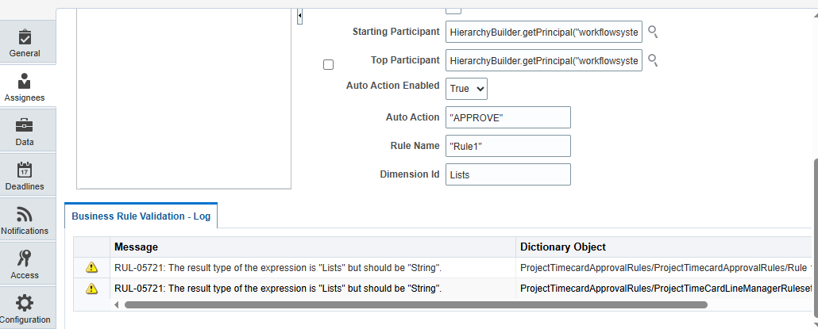
Figure C2. Earlier validation log showed RUL-05721 type errors (Lists vs String). These were corrected; a later validation completed with no errors.

5. Questions for OEG / Oracle specialist
- Why does the submitted Project Costing time card remain in Submitted status when the applicable task is ProjectTimecardApproval?
- What is the supported way to verify whether ProjectTimeCardApproval was launched for this time card, given that no task appears in Worklist/My Tasks and no corresponding transaction is visible in Transaction Console?
- For unconditional auto-approval, what exact list-builder/action configuration should be used in this Fusion release? Should the rule use the Supervisory list builder with Auto Action Enabled = True and Auto Action = APPROVE, or is any additional participant/task configuration required?
- Could any required profile option, scheduled process, workflow activation, BPM runtime setting, or time-card approval configuration prevent the task from being created?
- Are the IgnoreParticipant_V2 calls in TimecardApprovalRuleSet and ProjectTimeCardLineManagerRuleset valid for this configuration, and is there any additional required rule set or participant setup?
- What logs or diagnostic reports should be collected to identify the root cause without further altering delivered approval rules?

6. Expected outcome
After a valid project time card is submitted, the configured approval workflow should execute and automatically approve it (for the auto-approval test). Once approved, the time data should be eligible for transfer to Project Costing according to the Projects Only time consumer set configuration.

Additional notes
This is a test environment. The workflow rule configuration has been changed during troubleshooting, so please advise on the supported configuration for this release before recommending further changes. The screenshots represent different points in the troubleshooting process; the latest rule screenshot shows the Approval Group list builder, whereas an earlier screenshot shows the auto-approval action.

