1 ) Created a New User
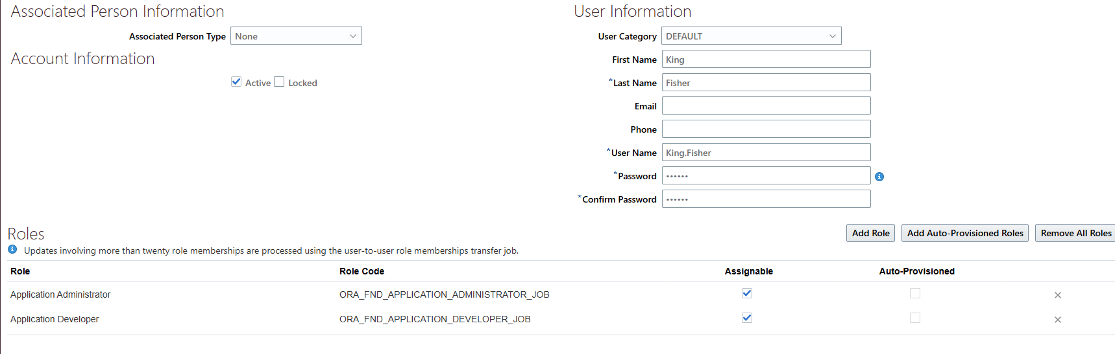
2 ) Ran the ESSJOB (8888116)
3) After the Job Ran successfully, I have submitted the below ESS Job(8888389)
4) I have submitted the Below Job
4) All three ESS JOBS ran to Success. 5) Successfully able to Login with the new User

6) When I click ConfigurationVisual Builder I get the below Error Message
